­­

**Mechanisms underlying higher order interactions: from quantitative definitions to ecological processes**

Andrew R. Kleinhesselink1, Nathan J.B. Kraft1, Jonathan M. Levine2,

1Department of Ecology and Evolutionary Biology, University of California, Los Angeles 621 Charles E. Young Drive South, Los Angeles, USA

2Institute of Integrative Biology, ETH Zurich, Switzerland

Running Head: *Higher Order Interactions*

**Key words:** *resource competition, interaction modification, phenology, annual plants*

Submission Type: Article

Main Text Word Count: ~5,190 (including abstract)

Total Word Count: 7160 (including appendix and literature cited)

Total Pages: 37 (including appendix)

Parts: Main text, Supporting Information Figures and Tables, Appendix A, Computer Code (zip file)

# Abstract

When species simultaneously compete with two or more species of competitor, higher order interactions (HOIs) can lead to emergent properties that are not present when species interact in isolated pairs. In order to extend ecological theory to multi-competitor communities, ecologists must develop a practical and general definition for HOIs that can be applied to a wide range of competition models. In this paper we propose a new general definition for HOIs that emphasizes the consequence of HOIs for modeling multi-species communities. Our definition will be valuable for empirical ecologists in need of clarity when discussing HOIs in empirical data. We compare our definition to previous definitions used by ecologists in the past. To show how our definition of HOIs can clarify their effect in empirical studies, we simulate resource competition between three annual plant species which differ in functional traits related to resource acquisition and resource conservation. We then fit a phenomenological competition model to the outcome of simulated competition and use the model fits to test for the presence of HOIs. In our simulations, we find the strength of HOIs varies with phenology: species that grow later experience stronger HOIs than earlier growing species. We conclude that HOIs are likely to occur in many communities. However, our simulation shows that HOIs are likely to be stronger in ecosystems where resource availability and individual size change rapidly throughout the course of the growing season and where there are strong differences between competitors in the rate of resource acquisition.

# Introduction

Almost all species interact with a diversity of predators, pathogens and competitors. Despite this, most classical models in community ecology assume that the per capita effects of each species on each other does not depend on the densities of any other species in the community. This simplifying assumption allows us to? predict the dynamics of multispecies communities from a model that only quantifies the interaction between each pairs of species (Chesson 2000, Levine et al. 2017). The concept of fixed per capita competition between species is also central to recent efforts to relate species’ functional trait differences to competitive dynamics (Kraft et al. 2015).

Higher order interactions (HOIs) between species invalidate the core assumption of fixed per capita interactions between species and this could have profound consequences for modeling community dynamics and species coexistence (Neill 1974, Mayfield and Stouffer 2017, Levine et al. 2017, Grilli et al. 2017). If HOIs are strong, even a perfect understanding of the interaction between each and every pair of species would not be sufficient to describe what happens when all the species are simultaneously interacting (Neill 1974, Billick and Case 1994, Levine et al. 2017). A specific example of the potential for HOIs to impact our understanding of community dynamics is in the application of the mutual invasibility criterion for determining the stability of coexistence (Levine et al. 2017). In theory, strong HOIs can allow three competitor species to coexist even where some pairs of competitors cannot coexist (Grilli et al. 2017).

Despite the theoretical importance of HOIs, measuring HOIs in nature has been impeded by shifting definitions of what does and does not count as an HOIs (Pomerantz 1981, Billick and Case 1994, Adler and Morris 1994). Moreover, previous definitions of HOIs were developed with a small range of classic competition models in mind. Since that time, improved statistical modeling software now allows ecologists to fit a much wider range of species interaction models (Mayfield and Stouffer 2017). This increase in model flexibility requires deriving a more general definition for HOIs that can be applied to any density dependent model of population dynamics. In the first part of this paper, we provide such a general definition for HOIs that accurately distinguishes HOIs from related phenomena such as non-linear density dependence and indirect effects. In the second part of the paper, we use a simulation experiment to illustrate how our definition can be applied. We also use this simulation to investigate possible mechanisms that could generate HOIs in nature.

## Higher order interactions result from interaction modification

To define? HOIs we focus on modeling a focal species’ performance (usually per capita population growth rate) as a function of competitor population density. This can be expressed generally as,

|  |  |  |
| --- | --- | --- |
|  |  | (0) |

where the left-hand side is the per capita growth rate of the focal species *i,* and *Fi* is a function of competitor densities (including intraspecific density) denoted by the vector **n**. In most widely used models of species interactions, each competitor has one effect on each species in the community, including itself. The simplest example of such a pairwise competition model is the Lotka-Volterra (LV) model,

|  |  |  |
| --- | --- | --- |
|  |  | (0) |

where, *ri* is the intrinsic rate of growth for the focal species *i* and is the per capita effect of competitor species *j* on the growth rate of the focal species. This model is pairwise because each interaction can be specified by the pair of species involved, *i* and *j*. A key property of any pairwise model, such as the LV model, is that the effect of each species on another is independent of the density of all *other* competitor species.

HOIs occur when the effect of one competitor species is modified by the density of another competitor species, also known as an interaction modification (IM) (Adler and Morris 1994); Figure 1). We can introduce an IM in the LV model by replacing any of the terms with a function that is dependent on another competitor’s density (Billick and Case 1994). For instance, in a pairwise model with two competitor species,

|  |  |  |
| --- | --- | --- |
|  |  | (0) |

replacing the term with the function makes the per capita effect of *n*1 dependent on the density of another competitor, *n*2, where is a coefficient measuring the IM. Substituting this function into the model introduces the product of competitors 1 and 2 as new term in the model:

|  |  |  |
| --- | --- | --- |
|  |  | (0) |

Interaction modifications such as this imply a meaningful change in the nature of an interaction between species. In this example, the IM between species one species two suggests specific biological hypotheses: the presence of one species modifies the behavior or traits of the second species, and in turn the competitive effects of the second species.

## A general definition of HOIs

While the basic connection between IM and HOIs is well understood, ecologists have yet to agree on a general definition for HOIs (Hairston et al. 1968, Billick and Case 1994, Grilli et al. 2017, Letten and Stouffer 2019). Here we offer our own general definition of HOIs and compare it with previous definitions. We define a model with HOIs as **any multispecies competition model that cannot be broken down into separate density dependent models for each species of competitor (Figure 1)**. By contrast, a model is pairwise and there are no HOIs if it can be broken down into a set of single competitor models without any loss of information. For instance, we can break the HOI model in (eqn 3) into two separate models, one for each competitor species,

|  |  |  |
| --- | --- | --- |
|  | (the response to competitor one)  , (the response to competitor two). | (0) |

However, this decomposition of the multi-competitor model results in the loss of the term The empirical significance of this is that there is no way to measure the coefficient from observations of separate single competitor gradients. By our definition this is an HOI resulting from an IM between species one and two.

We refer to the above as an example of a *hard HOI* and contrast it with the more general phenomenon of non-linear density dependence which produces what we term *soft HOI*s. A general test for soft HOIs is to take the partial derivative of the competition function, *F­i* in (1), with respect to the density of a single competitor species, *nj*: . This partial derivative is the mathematical definition of a single competitor species’ effect on the focal species. If this partial derivative is itself a function of competitor density, then there is some form of non-linear density dependence either in the model. This definition of HOIs is similar to that used in earlier discussions of HOIs (Case and Bender 1981, Letten and Stouffer 2019). However, as a definition for HOIs, this leads to the conclusion that every competition model except the linear LV model has HOIs (Pomerantz 1981, Adler and Morris 1994). For instance, the multispecies Hassel model (Hassell and Comins 1976),

|  |  |  |
| --- | --- | --- |
|  |  | (0) |

has the partial derivative . Thus, the effect of competitor *j* on the focal species *i* depends on the density of all other competitor species. Nevertheless, as in the LV model, the Hassel model does not imply hard HOIs as we define them because it can be decomposed into a set of pairwise interactions without loss of any information. For instance, for two competitor species:

|  |  |  |
| --- | --- | --- |
|  | (the response to competitor one)  , (the response to competitor two). | (0) |

In addition to the practical question of whether a model can be parameterized from observing each competitor’s effects separately, there are important ecological reasons to distinguish soft HOIs, as found in the Hassel model, from hard HOIs. First, soft HOIs between species can arise over discrete time intervals when the interaction between competitors is linear in continuous time (Hassell and Comins 1976, O’Dwyer 2018). In the case of the discrete time Hassel model, the lifetime competitive effect of each additional individual declines with competitor density because each individual competitor is smaller and thus has a smaller per capita effect on the focal species. Thus, while the effects of competition are non-linear, there is no ecologically meaningful IM between competitors other than their change in size—and this is implicit in the form of the model.

Another case where we can find an ecologically meaningful difference between hard and soft HOIs is in an example provided by Adler and Morris (1994). They describe a hypothetical scenario where different species of plants compete for light, with taller species reducing the amount of light received by shorter species. In their example, each species simply blocks a proportion of the light that passes through its canopy—thus the nature of the interaction between a tall species and a shorter one is independent of all other species. Nevertheless, this model of interaction means that the effect of a taller species on a shorter species below depends multiplicative on the density of any competitors with a canopy between the two. As in the Hassel model, per capita competition is non-linear, but arguably there is no ecologically meaningful IM between different competitors—they simply reduce the fraction of light received regardless of the presence of any other species. By contrast, hard HOIs as we define them require a distinct IM between competitors.

A related issue that arises in equating simple non-linearity with HOIs is that this would treat as HOIs non-linear responses to single competitor densities. For instance, recent papers by Letten and Stouffer (2019) and Mayfield and Letten (2017) defined HOIs as any higher order terms of competitor density, including single species terms, such as a single species quadratic term, . This definition does not fit with the emphasis among ecologists on HOIs as phenomenon that arises between two or more *different species* of competitor (Hairston et al. 1968, Vandermeer 1969, Neill 1974, Morin et al. 1988). Single species higher order terms can be interpreted as a kind of IM between individuals of the same species, i.e. the effect of each additional individual is modified by all other individuals. However, these single species higher order terms can be fully parameterized by observing the response of a focal individual to gradients of each species separately, thus they do not qualify as hard HOIs by our definition. Moreover, they do not lead to emergent properties in communities with two or more competitors that are not present in the set of single competitor communities.

Adler and Morris (1994) derived a test for HOIs based on the partial derivative of the population growth model with respect to competitor density, The Adler and Morris definition agrees with our definition in most cases however there are some cases where our definition and theirs differ and we believe ours is more general. In particular, their test for HOIs would indicate HOIs in any model in which there are different forms of density dependence for different competitor species. However, these types of models do not necessarily lead to emergent properties and so do not necessarily contain HOIs as we define them.

In the second half of the paper, we show how an ecologist could apply our definition to test for the presence of HOIs in empirical data. We use a mechanistic growth model to simulate resource competition among three annual plant species. We then fit species’ responses to interspecific competition using phenomenological competition models that do or do not hard or soft HOIs. Using our definition for HOIs above, we evaluate which species’ responses require a competition model with HOIs. By considering when HOIs emerge in this simple simulation we identify the steps required to detect HOIs in empirical data and shed light on the processes that could generate HOIs in nature.

# HOIs in a mechanistic resource competition model

We developed a mechanistic competition model intended to simulate the growth dynamics of annual plants in a Mediterranean climate. These systems are characterized by plants that germinate in the winter and grow, flower, and produce seeds by the early summer (Godoy and Levine 2013). In our model, we track a single pool of soil resources, most easily thought of as water or water-soluble nutrients. This pool is not resupplied during the season and is depleted overtime. As the resource concentration declines, plant growth slows and eventually stops. We make the assumption that when net growth is zero, the plant will convert a fraction of its biomass into seeds that will germinate at the start of the next growing season (Cohen 1976).

Resource dynamics in the model are given by the differential equation,

|  |  |  |
| --- | --- | --- |
|  |  | (0) |

where is the resource availability at time , is the resource supply rate, and the final term is the sum of resource uptake over all *m* species in the community. Biomass per individual of each species at time is given by and the number of individuals in the population is given by *ni*. The function *gi*(*b­i*) converts per capita biomass into surface area of fine roots. Total resource uptake rate is the product of root surface area and the rate of resource conductance per unit root surface area. The rate of resource conductance is a function, , of soil resource concentration. We simulate a Mediterranean climate by setting initial resource availability high, , and setting the resource supply rate, , to zero.

Growth of each species is given by a piecewise differential equation,

|  |  |  |
| --- | --- | --- |
|  |  | (0) |

where, *q* is the rate of resource conversion into biomass and is the rate of biomass loss and respiration. The inequalities indicate that when net growth of each species is less than or equal to zero, growth and resource consumption stops (i.e. is set to zero). Per capita biomass of each species, *bi*, is converted into per capita root surface area via the function , where *p* is the proportion of growth allocated to roots, *di* is root tissue density in g cm­-3 and is an exponent that scales root volume to root surface area (similar to Kooijmans (1986)). The rate of resource uptake per unit root surface area is dependent on resource concentration following Michaelis-Menton kinetics:

The equations above describe growth in biomass, *Bi*, over the course of days within a single growing season. In contrast, a population-level phenomenological competition model would track the total population density, *ni*, over annual time steps, . In order to convert population density into biomass we assume that individuals start the growing season as seeds with a fixed size. Thus, the initial biomass is, where is the mass per seed and is the number of seeds in the population in year *t*. The population density in the following year is equal to the number of seeds produced by the mature plants at the end of the growing season,

|  |  |  |
| --- | --- | --- |
|  |  | (0) |

where max is the final accumulated biomass of species *i* and *c* gives the proportion of total biomass converted to seeds.

We simulate the dynamics of three virtual annual plant species that differ in only two parameters: 1) root tissue density, *di* and 2) the rate of tissue loss and respiration, . We assume a trade-off between these parameters such that the rank of root density *di* among species is inverse to the rank of tissue respiration and loss rate, (Tjoelker et al. 2005, Birouste et al. 2014) (Figure 2c). Phenological difference, i.e. differences in growth over time, between the species naturally emerge from the differences in these traits (Figure 2). Species with lower root density convert each gram of biomass into more root surface area and this allows them to grow faster early in the season when resource concentrations are high. In contrast, species with denser roots but lower rates of tissue loss and respiration grow more slowly but continue growing later into the season as resource availability declines. Thus, we refer to the three species in our simulations as ‘early’, ‘mid’ and ‘late’, depending on when they stop growing during the simulation (Figure 2).

We used the model to simulate a virtual experiment in which each annual plant species is grown with a range of competitor densities. Each simulation lasts one growing season (200 days). After the simulation ends, we quantify the per capita seed output of each species and save this as a measure of population performance. We simulated each species performance across densities of 0, 1, 2, 3, 4, 9, 16, 25 or 36 individual competitors of each other species. Each species is tested against all possible combinations of two competitor species in an orthogonal design. We excluded scenarios in which all three species have densities greater than one to avoid fitting three-way HOIs. This design allows us to measure the pairwise effects between competitors as well as the presence of HOIs between species.

We chose parameters that produced growth and phenology patterns qualitatively similar to growth curves observed in annual plant communities (Godoy and Levine 2013). We provide a table of parameter values for the simulations in the supporting information (Table S 1). We simulate growth and resource dynamics by solving (7) and (8) using the package desolve in the statistical program R (R Core Team 2015).

## Phenomenological annual plant model

In order to investigate whether this simulation produces HOIs between the competitors, we fit three phenomenological competition models to the per capita seed production of each species. The first model is the Hassell model (Equation 6), where is the maximum per capita seed production, is the per capita competitive effect of species on and the denominator in the model is raised to the exponent where We specified an HOI version of the Hassel model as follows,

|  |  |  |
| --- | --- | --- |
|  |  | (0) |

where all two-species HOI effects on the focal species *i* are fitted with the coefficients (Mayfield and Stouffer 2017). By our definition, represents a hard HOI that can only be evaluated by measuring the per capita seed production of the focal species in cases where two competitor species are present (i.e. *nj* > 0 and ­*n­k* > 0).

Finally, we also considered a pairwise multiplicative model of the form,

|  |  |  |
| --- | --- | --- |
|  |  | (0) |

This model does not have HOIs per our definition. However, when there are two or more competitors the denominator becomes a polynomial with multiplicative terms of competitor density. Thus, contrasting this model with the HOI model allows us to test whether hard HOIs are truly required.

We first fit the Hassel model to only the pairwise cases and checked the model fit graphically. We then fit all three models to the full set of competitor densities. For each focal species and model, we calculated root mean squared error (RMSE) as a measure of goodness of fit. We evaluated the strength and direction of HOIs by examining the HOI coefficients, . To fit the models, we used the non-linear least squares modeling function, nls, in R. Code to run the simulations, fit the models and produce the figures is given in the online supporting information.

# Results

For all three species we found the Hassel model fit the simulated pairwise data accurately (Figure 3). Next, we compared the three phenomenological models fit to the full range of competitor densities (Figure 4). For the early season species, the Hassel model and the HOI model showed more or less equivalent fits to the data with only a slight decrease in RMSE for the HOI model (Figure 4 A&G). For the mid-season species, we found that the HOI model fit the data better than the Hassel model (Figure 4 B&H). The HOI model also fit the late season species better than the Hassel model (Figure 4 C&I). The inability of the Hassel model to fit the per capita seed output of the mid and late-season species can be seen by plotting the observed and per capita seed production against competitor density (Figure S1). The fitted HOI coefficients also showed strong HOIs for the mid and late season species but not for the early season species (Figure 5). In all cases, the fitted HOI coefficients, the , were of smaller magnitude than the fitted pairwise effects, the (Figure 5). The multiplicative model (eqn XX), did not fit the multi-competitor dynamics as well as the Hassel or the HOI models (Figure 4 D,E,F).

# Discussion

*Evidence for higher order interactions*

Our simulation shows clear evidence for HOIs affecting two of the three virtual species in our simulations (Figure 4 and Figure 5). For the mid-season and late season species, the strength of per capita competition changed depending on the presence of other interspecific competitors. Specifically, the presence of early season or mid-season species increased the per capita effects of competition on the late-season species (Figure 5 F). Likewise, the presence of the early season species increased the per capita effects of competition on the mid-season species (Figure 5 E). For the early season species, no clear HOIs were detected: the Hassel model fit the data nearly as well as the HOI model (Figure 4) and the magnitudes of the HOI coefficients were small (Figure 5D).

We observe competition in our simulations because of a feedback between individual density and resource concentration. As individuals grow, they draw down resource concentrations (Figure 2), this decreases the rate of resource flow into the roots and slows the growth of other individuals in the community. The magnitudes of pairwise interactions between species is easily understood from this perspective. For instance, the late season species has a weak per capita effect on the early season species, because when the early species is active (roughly day 0 to day 30) the late-season species is growing slowly and remains small (Figures 2 & 5). In contrast, the mid-season species has a stronger effect on the early season species because it grows faster during the same period (Figure 5). On the other hand, the early season species has a weak effect on the late season species because the former stops growing before the later does the majority of its growth (Figure 5).

The simplicity of the simulation makes it possible to understand how HOIs emerge in this system . The HOIs that affect the mid and late season species are due to an indirect effect of resource uptake on competitor size. For instance, in a scenario with one individual of each species, the early season species slows the growth of both the mid and the late-season species; this keeps them smaller later into the season and makes them both more sensitive to competition as the season progresses (Figure 2). This is reflected in the HOI coefficients for the mid and late-season species (Figure 5). In contrast, the early season species grows fast and exerts the dominant effect on resources while it is active, this makes any indirect effects on it mediated by changes in the size of its interspecific competitors negligible by comparison (Figure 5).

While the HOIs in this system are similar to competition mediated indirect effects (Levine et al. 2017) there are two important differences between the HOIs we observed and traditional indirect effects. First, indirect effects are not emergent properties of a multi-competitor system, rather they are a predictable result of pairwise per capita competition coefficients. Second, indirect effects emerge because of changes in the density of competitors over time, not because of changes in per capita competition coefficients. For example, one species may have an indirect effect on its competitor by changing the density of a second competitor over the course of several years. In contrast, the HOIs in our simulation emerge over the course of a single growing season with fixed population densities. Thus, these HOIs indicate ecologically meaningful changes in the per capita effect of one species on another. Our example can be contrasted with a recent simulation of forest dynamics that demonstrated how HOIs could affect species coexistence (Grilli et al. 2017). In that simulation, unlike ours, there were fixed per capita interactions between species. What the authors called HOIs in that model, were not due to changes in the per capita effects of competition, but were caused by changes in competitor density over time that were not explicitly tracked by the model.

*The phenomenological nature of HOIs*

HOIs can only be defined and quantified within the context of phenomenological models of competition. Phenomenological competition models simplify dynamics by only tracking population densities and not the resources for which species compete (Chesson 2000). HOIs may emerge in phenomenological models precisely because they leave out mechanistic detail and do not explicitly model resource dynamics (Abrams 1983, O’Dwyer 2018, Letten and Stouffer 2019). Given this, one might argue that HOIs are an artifact of the inadequacy of phenomenological models. However, we argue that any concept of species *interactions* is almost always phenomenological in nature; in most cases, competing individuals do not interact directly, rather they influence each other’s growth or survival indirectly through changes in shared resources. One could do away with interactions entirely and model populations and the resources they compete for (e.g. Dybzinski and Tilman (2007)), but measuring competitive interactions requires a phenomenological model, and thus requires confronting the issue of HOIs.

By assuming that resources concentrations are near a fixed equilibrium, phenomenological competition coefficients can sometimes be derived analytically from mechanistic competition models (Tilman 1977, Meszéna et al. 2006, Letten et al. 2017). However, in many natural systems, such as such as those involving annual plants, resource concentrations and individual size fluctuate rapidly over the course of a single growing season or generation. This makes deriving competition coefficients directly from the resource dynamics more difficult, perhaps impossible (O’Dwyer 2018). Thus, even in cases in which we actually know which resources species compete for, fitting a phenomenological models to population dynamics may be the only way we can summarize species interactions. Our work shows the importance of considering HOIs when moving beyond pairwise dynamics to multi-competitor settings.

*Are HOIs widespread?*

In our simulation model, HOIs arise because individual size, the trait that determines each species’ impact on and sensitivity to resource availability, is itself governed by resource availability (Meszéna et al. 2006). More generally, changes in individual size and corresponding changes in resource uptake rate may be a common cause of HOIs in nature. We predict that HOIs will likely be common in systems in which 1) some species can cause large resource fluctuations, 2) the per capita rate of resource uptake changes in response to resource availability, and 3) the strength of this response varies across species. Instead of changes in individual size, another mechanism that could generate HOIs would be density-dependent changes in resource acquisition traits. For example, traits such as height, specific leaf area, and phenology, have been shown to change in response to competition and resource availability (e.g. Aronson et al. 1992, Bennett et al. 2016, Conti et al. 2018). If per capita competition coefficients are a function of these traits, then it would not be surprising if changes in these traits led to HOIs. If changes in in individual size or trait plasticity can be so easily imagined to cause HOIs, this begs the question of why there have been so few documented examples of HOIs in natural communities (but see Mayfield and Stouffer 2017).

One hypothesis is that HOIs are common but usually too weak to detect. A key factor in producing HOIs in our simulation is that each species has a uniquely shaped growth curve and phenology. In additional simulations, we found that as species became more similar in their traits HOIs became weaker (Appendix A). In nature, such large functional differences in the way species take-up resources over time may be rare.

In addition, our simulation produces rapid changes in resource availability and average plant size. These changes cause changes in species interactions over the course of the season. Without these dynamics, species might have relatively constant per capita effects on one another and perhaps no HOIs would emerge. For instance, compare our system to an idealized version of resource competition experienced by competing perennial plants (Dybzinski and Tilman 2007). Due to their large size, perennial plants can be assumed to quickly draw resources down to a dynamic equilibrium. By contrast, seasonally forced systems such as annual plant communities in Mediterranean climates may be a good place to look for strong HOIs (Mayfield and Stouffer 2017).

# Conclusion

HOIs have profound implications for how we understand multispecies communities. We have provided a more general definition of HOIs that will be useful as more ecologists seek empirical evidence for HOIs in nature. In addition, by fitting HOIs to a simulated field experiment we show how an empiricist could go about measuring and discussing HOIs. This simulation also sheds light on the environmental conditions and life-history traits that may be more likely to generate HOIs. While we believe that HOIs should be common in nature this does not mean that they will be strong enough to detect statistically. Our work suggests that environments in which resource availability and competitor size change rapidly during a single growing season may be a likely place for strong HOIs to emerge.

# Acknowledgments

# References

Abrams, P. A. 1983. Arguments in Favor of Higher Order Interactions. The American Naturalist 121:887–891.

Adler, F. R., and W. F. Morris. 1994. A General Test for Interaction Modification. Ecology 75:1552–1559.

Aronson, J., J. Kigel, A. Shmida, and J. Klein. 1992. Adaptive phenology of desert and Mediterranean populations of annual plants grown with and without water stress. Oecologia 89:17–26.

Bennett, J. A., K. Riibak, R. Tamme, R. J. Lewis, and M. Pärtel. 2016. The reciprocal relationship between competition and intraspecific trait variation. Journal of Ecology 104:1410–1420.

Billick, I., and T. J. Case. 1994. Higher Order Interactions in Ecological Communities: What Are They and How Can They be Detected? Ecology 75:1530–1543.

Birouste, M., E. Zamora-Ledezma, C. Bossard, I. M. Pérez-Ramos, and C. Roumet. 2014. Measurement of fine root tissue density: a comparison of three methods reveals the potential of root dry matter content. Plant and Soil 374:299–313.

Case, T. J., and E. A. Bender. 1981. Testing for Higher Order Interactions. The American Naturalist 118:920–929.

Chesson, P. 2000. Mechanisms of Maintenance of Species Diversity. Annual Review of Ecology and Systematics 31:343–366.

Cohen, D. 1976. The Optimal Timing of Reproduction. The American Naturalist 110:801–807.

Conti, L., S. Block, M. Parepa, T. Münkemüller, W. Thuiller, A. T. R. Acosta, M. van Kleunen, S. Dullinger, F. Essl, I. Dullinger, D. Moser, G. Klonner, O. Bossdorf, and M. Carboni. 2018. Functional trait differences and trait plasticity mediate biotic resistance to potential plant invaders. Journal of Ecology 106:1607–1620.

Dybzinski, R., and D. Tilman. 2007. Resource Use Patterns Predict Long‐Term Outcomes of Plant Competition for Nutrients and Light. The American Naturalist 170:305–318.

Godoy, O., and J. M. Levine. 2013. Phenology effects on invasion success: insights from coupling field experiments to coexistence theory. Ecology 95:726–736.

Grilli, J., G. Barabás, M. J. Michalska-Smith, and S. Allesina. 2017. Higher-order interactions stabilize dynamics in competitive network models. Nature 548:210–213.

Hairston, N. G., J. D. Allan, R. K. Colwell, D. J. Futuyma, J. Howell, M. D. Lubin, J. Mathias, and J. H. Vandermeer. 1968. The Relationship between Species Diversity and Stability: An Experimental Approach with Protozoa and Bacteria. Ecology 49:1091–1101.

Hassell, M. P., and H. N. Comins. 1976. Discrete time models for two-species competition. Theoretical Population Biology 9:202–221.

Kooijman, S. A. L. M. 1986. Energy budgets can explain body size relations. Journal of Theoretical Biology 121:269–282.

Kraft, N. J. B., O. Godoy, and J. M. Levine. 2015. Plant functional traits and the multidimensional nature of species coexistence. Proceedings of the National Academy of Sciences of the United States of America 112:797–802.

Letten, A. D., P.-J. Ke, and T. Fukami. 2017. Linking modern coexistence theory and contemporary niche theory. Ecological Monographs 87:161–177.

Letten, A. D., and D. B. Stouffer. 2019. The mechanistic basis for higher-order interactions and non-additivity in competitive communities. Ecology Letters In Press.

Levine, J. M., J. Bascompte, P. B. Adler, and S. Allesina. 2017. Beyond pairwise mechanisms of species coexistence in complex communities. Nature 546:56–64.

Mayfield, M. M., and D. B. Stouffer. 2017. Higher-order interactions capture unexplained complexity in diverse communities. Nature Ecology & Evolution 1:0062.

Meszéna, G., M. Gyllenberg, L. Pásztor, and J. A. J. Metz. 2006. Competitive exclusion and limiting similarity: A unified theory. Theoretical Population Biology 69:68–87.

Morin, P. J., S. P. Lawler, and E. A. Johnson. 1988. Competition Between Aquatic Insects and Vertebrates: Interaction Strength and Higher Order Interactions. Ecology 69:1401–1409.

Neill, W. E. 1974. The Community Matrix and Interdependence of the Competition Coefficients. The American Naturalist 108:399–408.

O’Dwyer, J. P. 2018. Whence Lotka-Volterra?: Conservation laws and integrable systems in ecology. Theoretical Ecology.

Pomerantz, M. J. 1981. Do “Higher Order Interactions” in Competition Systems Really Exist? The American Naturalist 117:583–591.

R Core Team. 2015. R: A Language and Environment for Statistical Computing. R Foundation for Statistical Computing, Vienna, Austria.

Tilman, D. 1977. Resource Competition between Plankton Algae: An Experimental and Theoretical Approach. Ecology 58:338–348.

Tjoelker, M. G., J. M. Craine, D. Wedin, P. B. Reich, and D. Tilman. 2005. Linking leaf and root trait syndromes among 39 grassland and savannah species. New Phytologist 167:493–508.

Vandermeer, J. H. 1969. The Competitive Structure of Communities: An Experimental Approach with Protozoa. Ecology 50:362–371.

# Figures

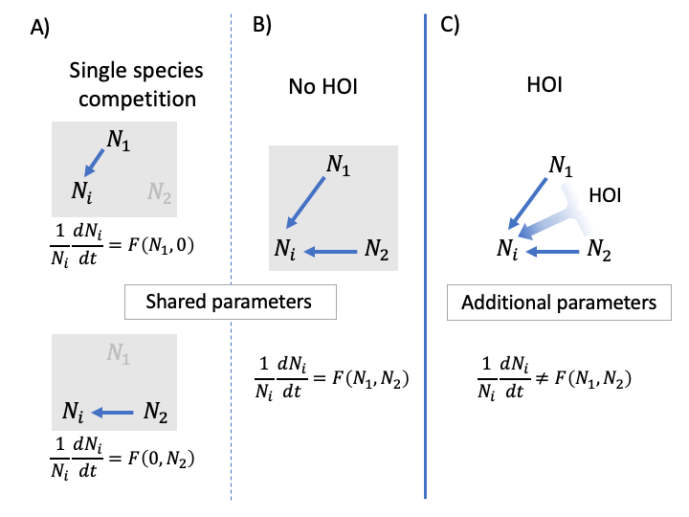

Figure 1. Conceptual definition of HOIs. In A, the competitive effects (blue arrows) of species 1 and 2 on the focal species are observed separately. The per capita growth rate of the focal species, *i,* is modeled as a function, *F*, of the density of competitor species 1 and 2. Importantly, all the information in *F* can be obtained by observing each competitor’s effects separately, as in A. In the communities in B and C, two competitor species are present together (i.e. *N*1 > 0 & *N*2 > 0). In B, the multispecies dynamics are predicted by *F*, and there are no HOIs. In C, the function *F* is not adequate to model the multispecies case; specifically, additional parameters are required to model the HOI that arises when competitor species one and two are present together.

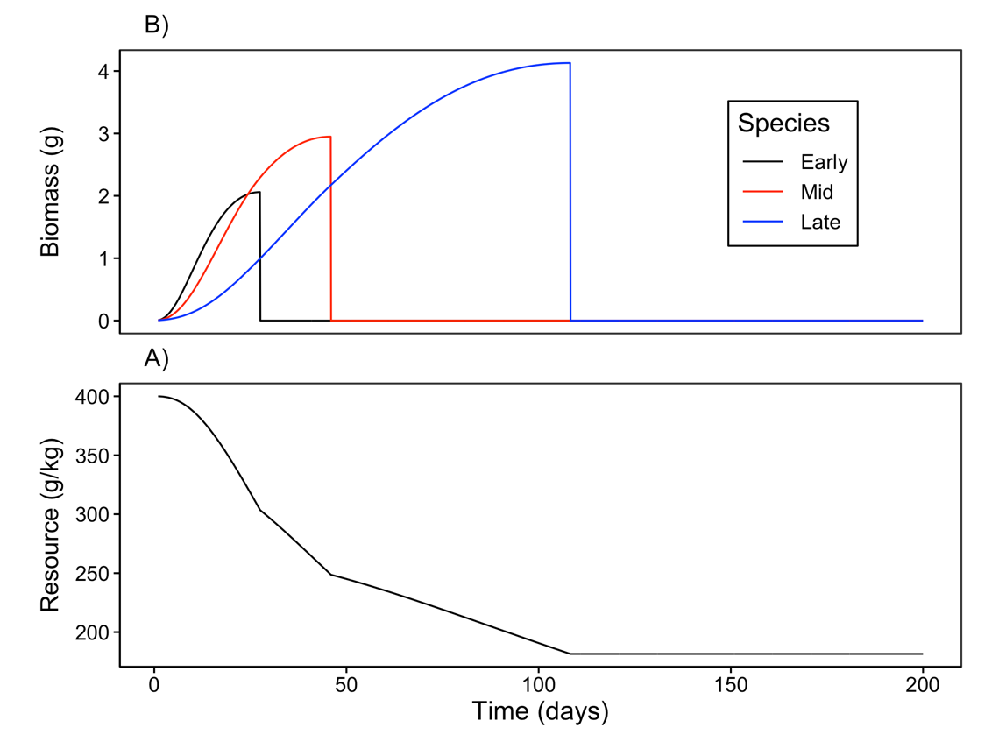

Figure 2. Example time course of A) annual plant growth and B) resource concentration during a single simulated growing season. In this example, each species’ population was initiated with one seed. The early season species (black) grows rapidly when resource availability is high and senesces early. By contrast, the late season species (blue) grows more slowly but grows later into the season as resource availability declines. The growth curve for the mid-season species (red) lies between these extremes.

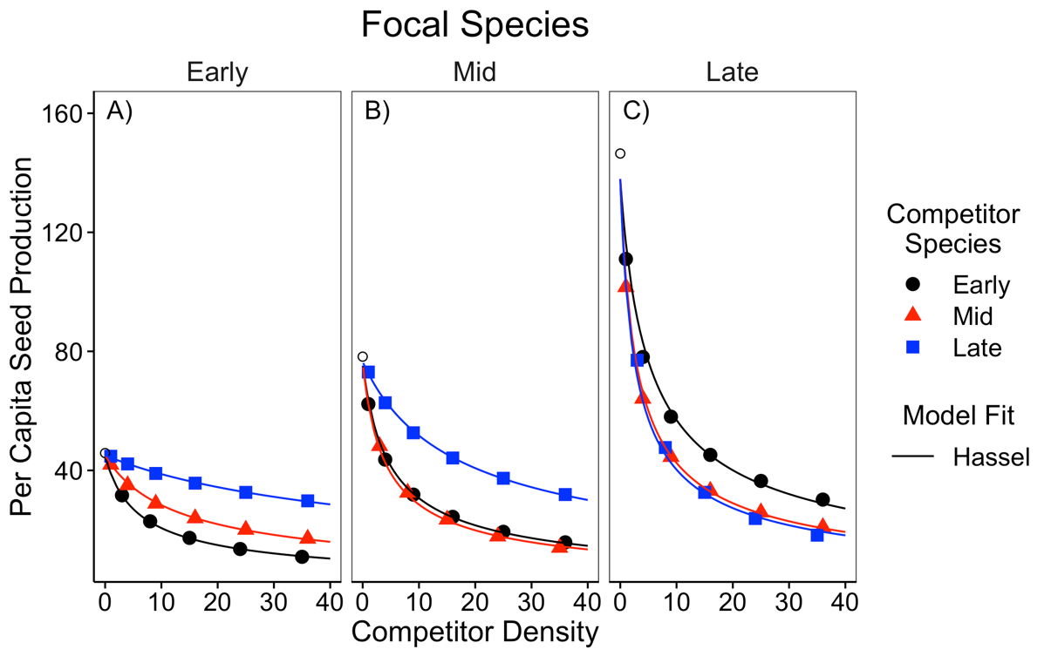

Figure 3. Simulated per capita seed production of the A) early, B) middle and C) late season species in response to a single competitor species at a time. Competitor density is shown on the x-axis. Colors and shapes indicate the identity of the competitor species. Open circles show the per capita seed production of each focal species in the absence of competitors. The solid line shows the fit of the Hassel model.

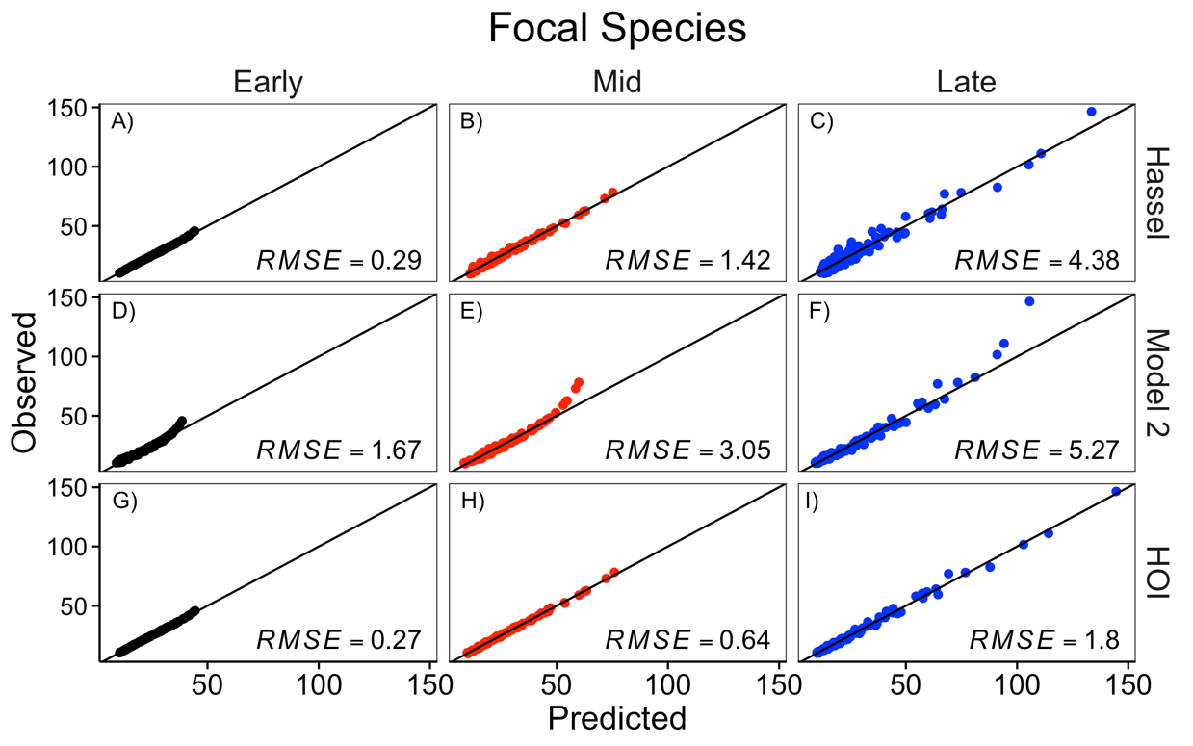

Figure 4. Comparison of the Hassel, multiplicative (model 2), and HOI models fit to each focal species. The y-axis shows the simulated per capita seed production of the focal species. The x-axis shows the per capita seed production predicted by the phenomenological model. The top row, A-C, shows the prediction for the Hassel model; the middle row, D-F, shows the prediction from the multiplicative model; and the bottom row, G-I, shows the prediction from the HOI model. The one-to-one line and root-mean-squared error (RMSE) for each model are shown on each panel.

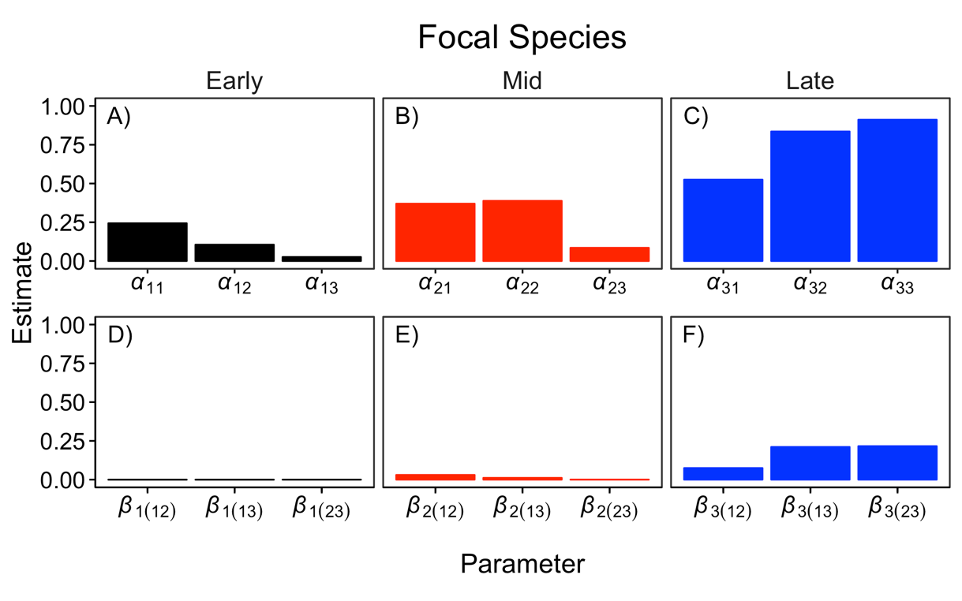

Figure 5. Interaction coefficients for each of focal species from the HOI model. The top row, A-C, shows the pairwise competition coefficients for the focal species and each competitor. The bottom row, D-F, shows the two-species HOI coefficients. Coefficient subscripts indicate which focal species and competitor species are involved, 1 = Early, 2 = Mid, 3 = Late.

# Supporting Information – Additional Tables

Table S 1 Table of parameter values used in the growth simulation experiment in the main text.

|  |  |  |
| --- | --- | --- |
| Parameter | Value | Definition |
| *U* | 200 | Duration of growth simulation (days) |
| *I* | 0 | Resource supply rate (g day-1) |
| *R(0)* | 400 | Initial resource concentration (g kg-1) |
| *d1* | 0.06 | Early competitor root density (g cm-3) |
| *d2* | 0.12 | Mid competitor root density (g cm-3) |
| *d3* | 0.36 | Late competitor root density (g cm-3) |
|  | 0.3 | Early competitor loss and respiration rate (g/g) |
|  | 0.15 | Mid competitor loss and respiration rate (g/g) |
|  | 0.053 | Late competitor loss and respiration rate (g/g) |
| *K* | 350 | Resource half-saturation constant (g kg-1) |
| *Vmax* | 1 | Maximum resource conductance (g d-1cm-2) |
| *p* | 0.5 | Ratio of root to total biomass |
| *nu* | 0.66 | Scaling exponent (unitless) |
| *q* | 0.2 | Biomass assimilation rate (g/g) |
|  | 0.005 | Seed mass (g/seed) |
| *c* | 0.1 | Conversion of final biomass to seed mass (g/g) |

# Supporting Information – Additional figures

# 

Figure S 1 Simulated per capita seed production of the A) early, B) mid and C) late season species in response to density of two interspecific competitors. Density of competitor species one is shown on the x-axis and density of competitor species two is shown with colors and shapes. Text in each panel lists the identities of competitor one and two (early, mid or late). Lines show best fit from the phenomenological models fit to the simulations. Residual sum of squared error is shown for each model and focal species.

# Appendix A – The effect of trait differences on higher order interactions

We used an additional simulation experiment to test whether the strength of higher order interactions (HOIs) was associated with the magnitude of functional differences between competitor species. We started with the same parameter values as in the simulation in the main text in which there was a large difference between the species in root density (*di*) and tissue respiration rate (*i*). In four additional simulation scenarios, we gradually decreased the average difference between species in these traits (Table A1). Specifically, we held the traits of the mid-season species constant and decreased the difference in the root density trait, *di*, between the early and late-season species. We assumed a trade-off between root density and tissue respiration rate such that changing root density also changed the tissue respiration rate, *i* (Figure A1). We quantified the average functional difference between species as the standard deviation of root density among all species. In each scenario, we simulated competition and fitted the phenomenological HOI model as in the main text. For each species in each scenario, we quantified the strength of HOIs as the average magnitude of the coefficients divided by the average magnitude of the coefficients. For the mid and late season species, the strength of the HOIs increased with the functional difference between species (Figure A1 B&C). For the early season species, HOIs were weak in all five scenarios (Figure A1 A). These simulations show that the functional differences between competitors drive the HOIs we observed in this system.

Table A 1. Parameter values for five simulations with gradually decreasing the trait difference between the early season and late season species. All other simulation parameters are the same as in Table S1.

|  |  |  |  |  |  |
| --- | --- | --- | --- | --- | --- |
| Functional  Difference | Scenario | Species | Root density *d*  (g cm-3) | Respiration rate *i*  (g g—1d-1) | Standard deviation of *d* |
|  | 1 | Early | 0.066 | 0.300 | 0.1460 |
| Large | Mid | 0.128 | 0.150 |
|  | Late | 0.343 | 0.053 |
|  | 2 | Early | 0.075 | 0.261 | 0.0821 |
|  | Mid | 0.128 | 0.150 |
|  | Late | 0.236 | 0.078 |
|  | 3 | Early | 0.088 | 0.222 | 0.0467 |
|  | Mid | 0.128 | 0.150 |
|  | Late | 0.181 | 0.104 |
|  | 4 | Early | 0.105 | 0.184 | 0.0208 |
|  | Mid | 0.128 | 0.150 |
|  | Late | 0.147 | 0.130 |
|  | 5 | Early | 0.132 | 0.145 | 0.0405 |
| Small | Mid | 0.128 | 0.150 |
|  | Late | 0.124 | 0.155 |

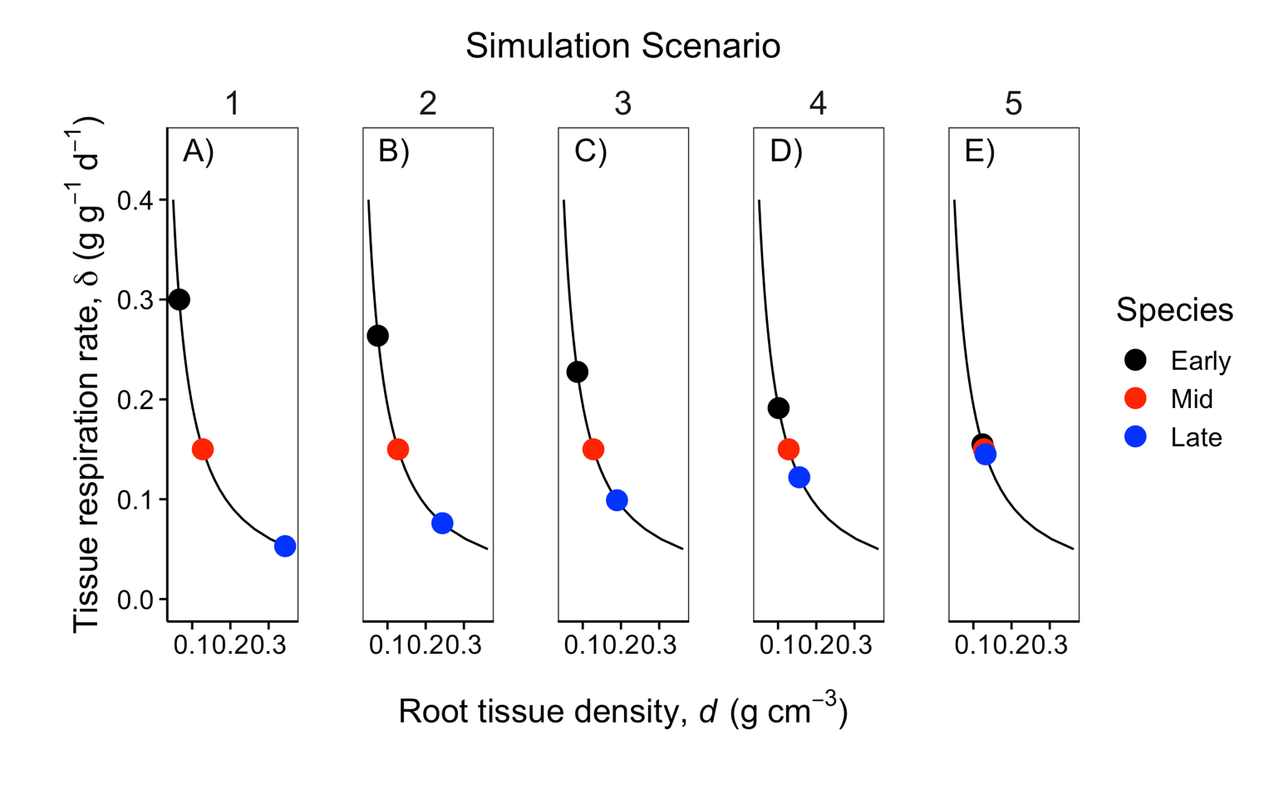

Figure A 1. Colored points show the value of functional traits, root density and tissue loss rate, for each of the three competitor species in each of the five simulation scenarios (A-E). Across the five scenarios, the differences between the early season and late season species’ root density and respiration rates were gradually decreased. The mid-season species’ traits were held constant. The black line indicates the trade-off between the root density and tissue respiration rate traits.

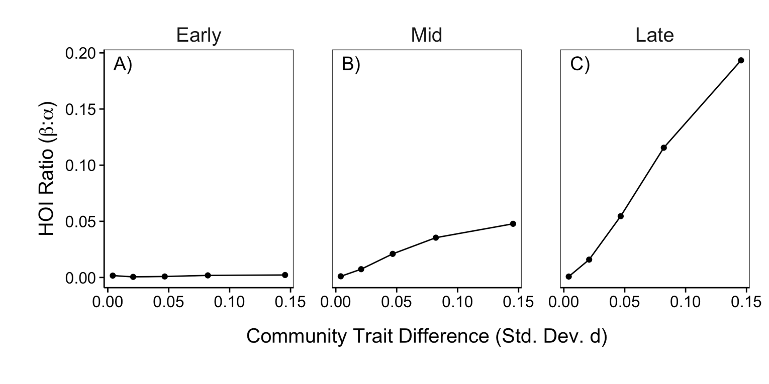

Figure A 2. The strength of HOIs depends on the difference in species functional traits. The y-axis quantifies the strength of HOIs affecting the early (A), mid (B) and late (C) species as the ratio of the of the average magnitude of the coefficients to the average magnitude of the coefficients in the phenomenological HOI model. A larger ratio ratio indicates stronger HOIs compared to pairwise interactions. The x-axis quantifies the community-level trait difference as the standard deviation of the root density “d” trait.